Social Network Analysis (Net-Map) Report for National Stakeholders
Submitted to
Nigerian Urban Reproductive Health Initiative (NURHI)
Abuja. Nigeria
By
Amina Mustapha

July, 2010
1.0 Introduction 2
2.0 Methodology 3
3.0 Net-Map Results 4
3.1 Actors Involved 5
3.2 Flow of Contraceptive 6
3.3 Flow of Money 8
3.4 Advocacy Flow 9
3.5 Influential Actors 11
3.6 Bottlenecks within the Network 13
3.7 Strategies for Improvement/Recommendations 14
4.0 Conclusion 15
Annex 1: Abbreviations used for Net-Map Actors 17
List of Tables 18
List of Figures 18

INTRODUCTION
The Nigerian Urban Reproductive Health Initiative (NURHI) is funded by Bill and Melinda Gates Foundation and an implementing consortium made of up John Hopkins University Center for Communication Program (JHUCCP), John Snow, Inc. (JSI) and also partners with Association for Reproductive and Family Health Nigeria (ARFHN) and the Centre for Communication Programs Nigeria (CCPN). NURHI’s vision is a Nigeria where supply and demand barriers to contraceptives use are eliminated, with a goal to increase the modern contraceptive prevalence rate in selected urban areas by at least 20 percent. NURHI has the following objectives:
- To develop cost-effective interventions for integrating quality family planning (FP) with Maternal, Neonatal and Child Health (MNCH), HIV/AIDS and post-abortion care (PAC) programs.
- To improve the quality of FP services for the urban poor.
- To test novel and innovative public-private partnerships approaches.
- To develop interventions for creating demand for and sustaining use of contraceptives.
- To increase funding mechanisms and a supportive policy environment for FP supplies and services.
NURHI focuses on urban areas and urban poor, and is strategically focused on integrating and reinforcing supply, demand, and advocacy as well as building on existing capacity and resources. NURHI has six operational sites in the country including: Abuja, Ibadan, Kaduna, Ilorin, Zaria and Benin City.
In a view to achieving the objectives of NURHI with regards to family planning services, it becomes crucial to have a better understanding about participants involved in influencing whether those who want to use modern contraceptives have access to them.
To better understand the actors involved in influencing better access to modern contraceptives and the structure of the network in which they operate, a participatory interview method, Net-Map, was used. Net-Map combines social network analysis, stakeholder mapping and power mapping in a participatory interview process that, when used in a group setting, allows for visualization of complex situations and consensus building. Findings from the Net-Map will allow for putting the different views in perspective, understanding the challenges, strong points, develop momentum and strategic plans for further network development.

2.0 METHODOLOGY
The Net-Map process was undertaken in the form of a key stakeholder group interview. A group of key national stakeholders were invited to a stakeholder meeting in NURHI office, Abuja where one Net-Map was drawn. The structure of the Net-Map interview, as determined by the NURHI staff, was as follows:
- Research Question: Who influences whether those who want to use modern contraceptives have access to them?
- Who are the relevant actors?
- What are the critical links between these actors?
  - Flow of contraceptives
  - Flow of money
  - Advocacy link
- How influential are the actors over this specific issue?
- What are the bottlenecks, problems and stumbling blocks that stop modern contraceptives from being available to the people who need them?
- What are the strategies for improving the availability of modern contraceptives?
Data collected was later entered into Excel and analyzed using the Visualyzer 2.0 software.

- NET-MAP RESULTS

Table 1: Actors influencing whether those who want to use modern contraceptives have access to commodities.
Actor | Actor Group Type
Manufacturers | Manufacturers
Federal Ministry of Health | Government
State Ministry of Health | Government
Local Government Authority | Government
Millennium Development Goal’s office | Government
Federal Ministry of Finance | Government
Legislators | Government
NAFDAC | Government
United Nations Fund for Population Activities | Donor
United states Agency for International Development | Donor
Department for International Development | Donor
Bill and Melinda Gates Foundation | Donor
Packard Foundation | Donor
Warren Buffett | Donor
International Planned Parenthood Federation | Implementing Partners
IPAS | Implementing Partners
Plant Parenthood Federation of Nigeria | Implementing Partners
Society For Family Health | Implementing Partners
Marie Stopes Nigeria | Implementing Partners
John Snow, Inc./DELIVER | Implementing Partners
Medical Women Association of Nigeria | Implementing Partners
Health Facility Providers | Providers
Community Based Distributors | Providers
Pharmacies | Providers
Patent Medicine Vendors | Providers
Private Provider | Providers
Tertiary Institutes (Teaching Hospitals) | Providers
Users | Beneficiary
Federation of Muslim Women Association of Nigeria | NGO
Christian Health Association of Nigeria | NGO
National Council for Women Society | NGO
Other Non-Governmental Organisations | NGO
Religious Leaders | Opinion Leaders
Community Leader | Opinion Leaders
Husbands | Beneficiary
Media | Media Houses

  - Actors Involved
The actors involved in influencing whether those who want to use modern contraceptives have access to the commodity are many. A total of 36 actors were placed on the map with each actor being relevant. Table 1 (above) present all the stakeholders that influence whether those who want to use modern contraceptives are having access to the commodity. The actors on the Net-Map include; Government which is a key player for its role in policy formulation and implementation as well as creating an enabling environments for other participants to operate. Government was however broken down into the various agencies that play a role in influencing whether those who want to use modern contraceptives have access to the commodity.

Federal Ministry of Health, State Ministry of Health and the Local Government Health Authorities are all government ministries that have a direct link with family planning services in Nigeria. While the Federal Ministry of Finance is not directly linked with family planning but plays an important role in budgetary allocation and release of funds for use by Federal Ministry of Health. Another important government actor on the map is NAFDAC which is a government regulatory outfit that regulates and registers all foods and drugs in the country. Millennium Development Goal’s office is also under the government but its operations are targeted towards achieving the millennium development goals. The final stakeholders grouped under the government are the legislators who are also important in policy formulation and implementation.

The second group of actors placed on the Net-Map is the donor agency or development partners. They are the international partners that provide the fund for family planning services in Nigeria and they include; USAID, DFID, UNFPA, the Bill and Melinda Gates Foundation, Packard Foundation and Warren Buffet. The implementing partners are international NGOS that partner with the Nigerian government in providing family planning services to those who want to use the commodity; they are different from other local NGOS because they have been identified by donors as partners in carrying out family planning programs and activities. These partners include; International Planned Parenthood Federation (IPPF), Planned Parenthood Federation of Nigeria (PPFN), Society for Family Health (SFH), Marie Stopes Nigeria (MSN) and John Snow Incorporated/Deliver (DELIVER). Medical Women Association of Nigeria is the only national organization that is in this group, but they are also implementing partners.

The fourth groups of actors are called the providers, they are important because of their role in getting the contraceptives to the user. They differ from implementing partners because they are found at the local level and are the providers of the commodity to the users. The providers that were placed on the Net-Map include; Health Facility Providers (HFCs), Community Based Distributors (CBDs), Pharmacy, Patent Medicine Vendors (PMVs) and Private Providers (PPs). Federated Organization of Muslim Women Association (FOMWAN), Christian Health Association of Nigeria (CHAN), National Council for Women Society (NCWS) and the other NGOS are all nongovernmental organizations operating at different levels in the country. However, these NGOS differ from implementing partners in that they receive sub contract from the implementing partners and also do not typically provide direct service to users.
Other stakeholders on the Net-Map are Community and Religious leaders who are also important opinion leaders found at various levels of the government. They also play an important role in influencing whether those who want to use modern contraceptives have access to the commodity because they are usually gatekeepers wherever they are found. Specifically, for example, a church pastor who preaches in favor of family planning will do much to influence members of the congregation to use contraceptives. Similarly, a community leader who opposes family planning will curb community members’ desire to use modern family planning methods. Tertiary Institutions (Teaching Hospitals) were also placed as separate actors on the map and not grouped with providers because they get contraceptives direct from the federal level unlike other providers. Users accessing family planning services from these tertiary institutes also pay extra costs for services rendered. Both The user and husbands were also identified as key players in the net-map. The last stakeholder is the media, who are important especially with regards to advocacy and creating demand for contraceptives.
3.2 Flow of Contraceptive
Figure 1 (below) present the links in respect to the flow of contraceptives in Nigeria. The Net-Map depicts that the flow of contraceptives in Nigeria is not decentralized; rather there is a central distribution link with the Federal Ministry of Health playing a central role in the flow of contraceptives. The commodity flow directly from a foreign manufacturer to Federal Ministry of Health (FMOH) from where the commodity is later distributed to the State Ministry of Health (SMOH), Society for Family Health (SFH), PPFN and the teaching hospitals.
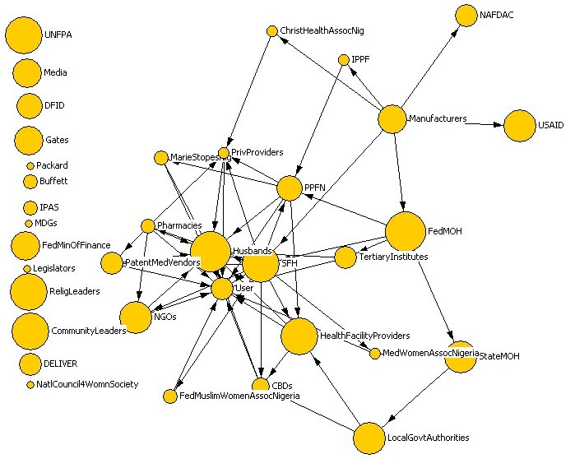
Figure 1: Net-Map of Flow of contraceptives with National Stakeholders
Each actor in the network is represented by a circle, whose size indicates relative influence (as seen by participants) with regards to whether or not users have access to modern contraceptives. Arrows indicate the flow of links. Actors in the margin were not actively identified as participating in the physical flow of contraceptives.
There is however a direct flow of contraceptives from the foreign manufacturers to Society for Family Health, being a leader in social marketing in contraceptives and also having a strong funding base from USAID and DFID. Society for Family Health (SFH) is the major distributor of contraceptives in Nigeria; it distributes contraceptives to both public and private providers as well as Nongovernmental organizations. Planned Parenthood Federation of Nigeria (PPFN) receives its contraceptives directly from the manufacturer through IPPF. NAFDAC does not collect contraceptives from manufacturers but rather, it serves as the government’s regulatory agency where all foods and drugs coming into the country must pass through for certification and registration.
Contraceptives do not typically pass through the donors. The flow of contraceptives to the user is through the providers and sometimes through some of the implementing partners and nongovernmental organizations, but the bulk of contraceptive that reaches the user is through the providers who receive contraceptives directly from SMF, PPFN and Other NGOS. The providers are actually the stakeholders operating at the local level close to the user. Contraceptives generally flow from the top to the bottom with the government and implementing partners playing a key role in the distribution chain. Exchange of contraceptives between implementing partners is also common in the network. This happens specifically when partners run out of stock. All actors placed on the left hand corner are not involved in the flow of contraceptive in the network.
3.3. Flow of Money
Figure 2 (below) is the Net- Map for the flow of money in contraceptive delivery in Nigeria. For the contraceptives commodity to move from the manufacturer to the ultimate user there is a need for exchange of money for procurement and distribution. Even though FMOH is a central actor in the flow of contraceptives from the manufacturer to other actors on the map, they do not have any money link going out of the ministry indicating that funds for the contraceptives distributed in Nigeria does not come from the ministry but from other sources. This can clearly be seen from the map as the position of the ministry has shifted from its earlier central position in the contraceptive flow map. There are only three money links directed towards FMOH from SMOH, Tertiary Institutes and SFH in exchange for commodity received
Majority of the money links are directed towards SFH in exchange for contraceptives since they are the major suppliers at the local level, there are also money links going out from the user towards all actors that provide the contraceptives. The media has direct money link from other actors mostly for advocacy on demand creation. Stakeholders standing out at the corner of the map are not involved in money flow.

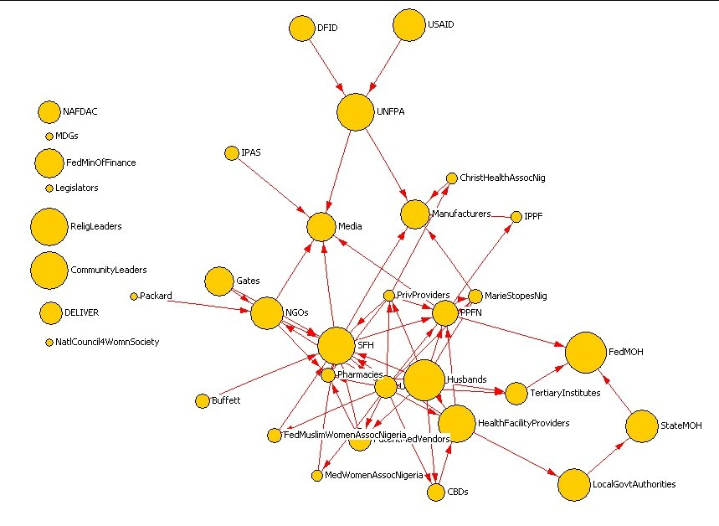
Fig 2: Net-Map of Flow of Money with National Stakeholders

  - Advocacy Flow
The last link in the Net-Map for the National stakeholders is that of advocacy. Advocacy is in various forms depending on the actor and interest to be promoted. Advocacy can be in the form of a formal meeting to request for different types of support. In some advocacies, money supplies are also often requested. Example the Federal Ministry of Health (FMOH) advocating to the MDGs office for the release of funds for contraceptives, but since the MDG office has many other areas of interest FMOH must be able to convince MDG to provide funds for contraceptives. Most of the advocacy directed towards FMOH from donors, implementing partners and SMOH is more of support in terms of policy formulation and creating an enabling environment for the implementing partners. An enabling environment is when government creates policies that favour family planning which will make it easier for implementing partners to provide access to contraceptives. A typical example here is when government support integrated services where all basic kinds of health care services and supplies are available.
Religious and community leaders are also paid advocacy visits. This advocacy is to convince them to talk to their followers about family planning because they are well connected multipliers in their community and therefore important stakeholders in the creation of awareness for the use of contraceptives in their communities.
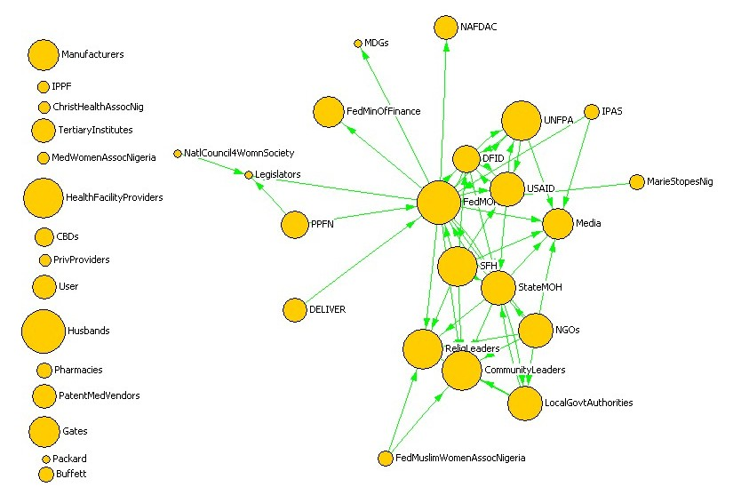
Fig 3: Net-Map of Advocacy Flow with National Stakeholders

  - Influential Actors
Table 2 (below) shows the level of influence that each of the actors has on making sure that everyone who wants to use modern contraceptives has access to them. Starting with the most influential actors, the Federal Ministry of Health’s (FMOH, 10) influence comes from its position as the central government ministry that is directly involved in the procurement and distribution of contraceptives in Nigeria without whom the system will collapse. Husband’s (10) are also very influential because the decision on whether to use or not to use the contraceptive is usually made by them. The husband’s support usually allow the user have access to the commodity. Donors are highly influential stakeholders because they are the providers of funds for procuring contraceptives by the FMOH, UNFPA (9) is particularly influential for not only providing funds but also for forecasting and procuring on behalf of the government.
ACTOR | INFLUENCE TOWER SCORE | GOAL
Federal Ministry of Health | 10 | Supportive
Husband | 10 | Neutral
United Nations Fund for Population Activities | 9 | Very supportive
Society For Family Health | 9 | Very Supportive
Health Facility Providers | 9 | Supportive
Religious Leaders | 9 | Neutral
Community Leader | 9 | Neutral
State Ministry of Health | 8 | Supportive
Local Government Authority | 8 | Supportive
United states Agency for International Development | 8 | Very supportive
Non Governmental Organisations | 8 | Supportive
Manufacturers | 7 | Neutral
Federal Ministry of Finance | 7 | Unsupportive
Bill and Melinda Gates Foundation | 7 | Very supportive
Media | 7 | Neutral
Department for International Development | 6 | Very supportive
Plant Parenthood Federation of Nigeria | 6 | Supportive
NAFDAC | 5 | Neutral
John Snow, Inc./DELIVER | 5 | Very supportive
Patent Medicine Vendors | 5 | Supportive
Users | 5 | Supportive
Tertiary Institutes (Teaching Hospitals) | 5 | Supportive
Community Based Distributors | 4 | Neutral
Warren Buffett | 3 | Very supportive
IPAS | 3 | Supportive
Marie Stopes Nigeria | 3 | Supportive
Pharmacy | 3 | Supportive
Federation of Muslim Women Association of Nigeria | 3 | Supportive
International Planned Parenthood Federation | 2 | Supportive
Medical Women Association of Nigeria | 2 | Neutral
Private Provider | 2 | Unsupportive
Christian Health Association of Nigeria | 2 | Neutral
Millennium Development Goal’s office | 1 | Neutral
Legislators | 1 | Unsupportive
Packard Foundation | 1 | Very supportive
National Council for Women Society | 1 | Supportive
Table 2. Influence Tower for Net-Map of National Stakeholder

The influence of religious (9) and community leaders (9) is also reflected in the Net-Map because of the strong tie existing between them and their followers. They often use the influence to create demand for the use of contraceptives. State Ministry of Health, Local Government Authorities (8) and Health Facility Providers (9) are also influential stakeholders in the Net-Map because they play a central role in the distribution of contraceptive at the state and local level. Society for Family Health (SFH, 9) is the most influential implementing partner because they have the largest family planning projects in Nigeria and also the widest outreach at the community level. Other NGOs and the media were also scored high; NGOs (8) for providing the contraceptives to the user and the media (7) for creating demand from the user. Medical Women Association of Nigeria (MWAN, 2), Christian Health Association of Nigeria (CHAN, 2) as well as Millennium Development Goal’ office (MDG, 1) and Legislators (1) are not very influential in the network. Annex 2 presents a combined Net-Map for contraceptive flow, money flow and advocacy flow.

  - Bottlenecks within the Network
Several bottlenecks were identified within the network at both National, State and local government level as well as from the implementing partners. These challenges contribute to low level of access to modern contraceptives.
Federal Government
Some governmental procedures were seen as actually hindering the processes of getting contraceptives down to the user. There are delays in terms of approval for the release of funds as well as delays in accessing approved funds. In addition, logistical issues often cause disruptions. Even though the distribution of contraceptives in Nigeria is centralized with the Federal Government, who is solely responsible for distribution of the commodity, there is inadequate support for logistics in terms of both infrastructure and transportation. Net-Map participants articulated that problems with logistics in Nigeria lead to contraceptives expiring in warehouses instead of users having access to the commodities. In their view, conflicting interests and misplaced priorities, coupled with the absence of dedicated a budget line for family planning logistics in Nigeria also leads to donor fatigue.
State Government
Challenges were also identified at the level of the state government. Some of the bottlenecks identified include; the attrition of trained family planning personnel from health facilities leaving for greener pasture elsewhere, this leads to the creation of gaps in the area of family planning services. There is also inadequate capacity or uniform format for monitoring of information and also poorly motivated and overburdened staff at the health facility centres.

Implementing Partners
The bottlenecks identified within the network are not limited to the government alone. There were also problems arising from the implanting partners, some of the identified bottlenecks included; Dwindling donor funding arising from shift in policy, vertical programs by donors as well as conflicting terminologies and messages for the same family planning service from donors and implementing partners. Vertical programs by donors is a situation where projects and services by donors are not done in an integrated way, the perspective in vertical programs is not that of the people but rather donors and other high level actors. Associated with vertical program is uncoordinated and multiple training of provider on the same family planning service by the implementing partners. The problem of rivalry existing among implementing partners and also multiple data entry forms for the same provider and the same service is also a serious issue that acts as a stumbling block for efficient service delivery.
Community Level
The major challenges that act as a stumbling block to family planning services at the community level are socio- cultural and religious beliefs, as well as myths and misconceptions about family planning (e.g. FP is only for women who have finished having children). There is also the issue of improper engagement of community and religious leaders in family planning programs at the community level. Finally, problem of inadequate provider capacity exists at the community level as well as negative attitudes and lack of commitment by provider towards the client. Absenteeism at work as well as poor interpersonal communication between providers and client also negatively impact users’ access to contraceptives.
  - Strategies for Improvement/Recommendation
Given the challenges discussed above regarding users’ access to modern contraceptives, Net-Map interviewees recommended the following strategies to improve the availability of contraceptives in Nigeria:

- There is a strong need for decentralizing the distribution of contraceptives at regional level.
- Participants also also a strong need for the establishment of organized contraceptive distribution system to be handled by private logistic company; this will go a long way in solving the logistic problem mentioned above.
- Training and retraining of service providers on logistic management system is also crucial in improving the distribution of contraceptives in Nigeria.
- There should also be a well structured advocacies targeted toward policy makers for budgetary allocation in family planning programs in Nigeria, this will help in solving the problem of donor fatigue.
- Family planning champions should also be made among the legislators, governors and first ladies.
- Strengthen resource mobilization efforts to individual philanthropists, foundations and corporate organizations in the country
- Making family planning commodity free at certain level of the community can also be a good strategy.

- Conclusion
Net- Map was drawn for national stakeholders on the key players involved in influencing whether those who want to use modern contraceptive are having access to the commodity using three identified links; Flow of contraceptive, flow of money and advocacy as a guide. Findings from the result revealed that many stakeholders are involved right from the national level through to the level of the community, a situation that presented a complicated Net-Map. The Federal Ministry of Health is at the centre of the contraceptive flow being the government that is solely responsible for the distribution of contraceptives in Nigeria. The government position however moved from the centre outward in the Net-Map for the flow of money indicating that the government is not playing an important role in funding family planning programs in Nigeria. The donor agencies and implementing partners are the influential actors as far as funding of family planning programs in Nigeria is concerned. FMOH however regained its central role in the centre of the Net-Map for several advocacy link directed towards it from several implementing partners advocating to the government for support and provision of enabling environment for them to operate. Media, community and religious leaders have several advocacy link directed towards them at both national and community levels.
problems of resources and logistics have also been identified as serious bottlenecks. Donor agencies and implementing partners are the major provider of funds for family planning programs in Nigeria

Annex 1: Abbreviations used for Net-Map Actors

ACTOR | ABBREVIATION | SECTOR
Manufacturers | Manufacturers | Government
Federal Ministry of Health | FedMOH | Government
State Ministry of Health | StateMOH | Government
Local Government Authority | LocalGovtAuthorities | Government
Millennium Development Goal’s office | MDGS | Government
Federal Ministry of Finance | FedMinOfFinance | Government
Legislators | Legislators | Government
NAFDAC | NAFDAC | Government
United Nations Fund for Population Activities | UNFPA | Donor
U.S. Agency for International Development | USAID | Donor
Department for International Development | DFID | Donor
Bill and Melinda Gates Foundation | Gates | Donor
Packard Foundation | Packard | Donor
Warren Buffett | Buffett | Donor
International Planned Parenthood Federation | IPPF | Implementing Partners
IPAS | IPAS | Implementing Partners
Plant Parenthood Federation of Nigeria | PPFN | Implementing Partners
Society For Family Health | SFH | Implementing Partners
Marie Stopes Nigeria | MarieStopesNig | Implementing Partners
John Snow, Inc./DELIVER | DELIVER | Implementing Partners
Medical Women Association of Nigeria | MedWomenAssocNigeria | Implementing Partners
Health Facility Providers | HealthFacilityProviders | Providers
Community Based Distributors | CBDs | Providers
Pharmacy | Pharmacies | Providers
Patent Medicine Vendors | PatentMedVendors | Providers
Private Providers | PrivProviders | Provider
Users | User | Beneficiary
Federation of Muslim Women Assoc. of Nigeria | FedMuslimWomenAssocNigeria | NGO
Christian Health Association of Nigeria | ChristHealthAssocNig | NGO
Non Governmental Organisations | NGOs | Other NGOS
National Council for Women Society | NatlCouncil4WomnSociety | NGO
Religious Leaders | ReligLeaders | Opinion Leaders
Community Leader | CommunityLeaders | Opinion Leaders
Husbands | Husbands | Husband of User
Tertiary Institutes (Teaching Hospitals) | TertiaryInstitutes | Teaching Hospitals
Media | Media | Media Houses

Annex 2. Net-Map of all links with all national stakeholders.
(Green=advocacy, Black=contraceptives, Red=money)

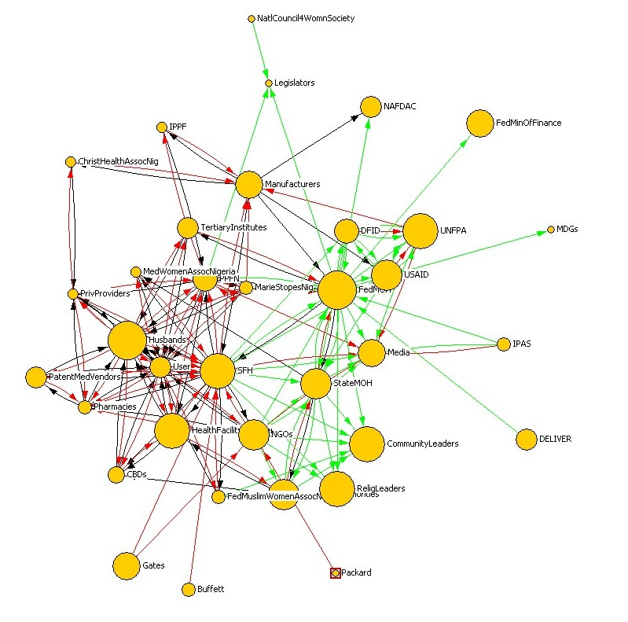

See Annex 2 for a complete Net-Map

