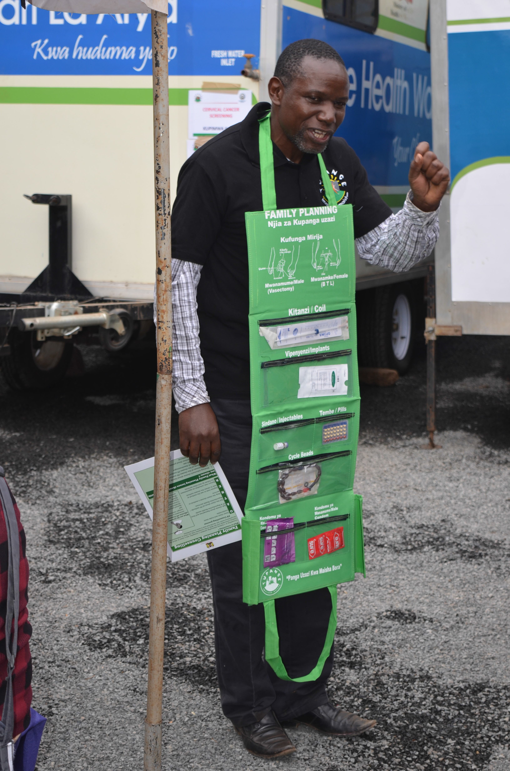DRAFT

Ministry of Health
Reproductive Maternal Health Service Unit

Guide for Conducting Integrated
Reproductive Health Outreaches

July 2016

Table of Contents
- Acknowledgments 2
- Foreword 2
- Definitions 4
- Rationale 4
- Planning and logistics 5
- Selecting and Outreach Site 5
- Roles and responsibilities 6
- Integration of Services 6
- Client rights during Outreach Services 7
- Implementation of Outreach Services 8
- Monitoring and Evaluation 9
- Post camp follow up 9
- Possible challenges to consider 10
- Summary of main activities 11
- Appendices
  - Outreach equipment/supplies checklists 12
  - FP Commodities checklist 16
  - FP equipment checklist 17
  - Infection prevention 19
  - FP provision screening checklists 21
  - Consent form for surgical contraception 25

Foreword

Outreach health services form part critical component of the health service delivery in Kenya. Ministry of health, county governments and several development partners have over the years been involved in integrated RH outreach health services.

Acknowledgments

The RMHSU wishes to thank all persons who were involved in the development of this document in one way or the other. Particular
appreciations go to teams from;
- Tupange Project
- Jhpiego
- Mariestopes Kenya
- RMHSU Family Planning team

Preparation and printing of this document was made possible by support from Tupange - The Kenya Urban Reproductive Health Initiative.
However, there has been no systematic document
to guide program managers, County and sub county health management teams and other stakeholders to effectively organize and conduct integrated RH outreaches. These guide forms part of the tools
necessary to effectively organize and conduct RH/FP outreach health services.

This guide is intended to be used by County /sub county health management teams, program managers, health facility in-charges , service providers and Community Health Volunteers involved in RH/FP outreach health services

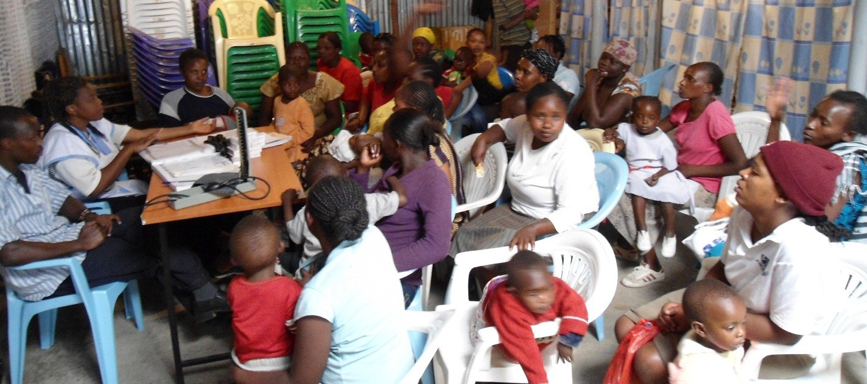

What is a RH/FP Outreach Health Service?

An outreach health service is defined as RH/FP service provided by a mobile team of trained service providers. Community mobilization is done prior to the activity. The outreach services may be provided at:
- Lower-level health facilities. When activities are conducted within the health services,
they are referred to as In-reach services.

- Locally available community facilities such as schools, social halls, community grounds, markets and churches.
To provide appropriate working space, and ensure mobility from site to site, an outreach ser- vice may be conducted using mobile health units such as trailers (wagons) or modified self- contained trucks.

Rationale for Conducting RH/FP Outreach Health Services
- Unmet need for family planning in Kenya is relatively high at 18%. Unmet need for FP is even higher (28.6%) among women in the lowest quintiles (KDHS, 2014). Even where FP methods may be available, contraceptive choice is limited primarily to short term methods. Outreach services therefore serve as additional opportunities to address this need, including for long acting and permanent methods
- Outreach services may also serve to eliminate barriers to accessing services, particularly where health facilities are located far away or if the community has negative attitudes to sur- rounding health facilities. Out-reach services may be more affordable (or offered free) than facility health services hence helping to improve access to poor populations.
- Outreach FP/RH services serve as opportunities for closer interaction between heath facility staff and the community. Such interactions foster community dialogue and assist to initiate community action.

Planning and Logistical Arrangements

Needs Assessment
Involves review of county/ sub county and facility data to identify geographic areas needing scale up of FP/RH services, types of services to be included in the FP/RH outreach. Additional information can also be obtained from Community Health Volunteers.

Resource Identification
There are a number of resources needed for mobile outreach services; it is important to see what is available, what is needed and based on this which is the most effective way to conduct outreach services.

Collaboration and Partnership
Managers need to consider partnering with as many collaborators as possible to share the costs involved in conducting outreach activ- ities. Collaboration should be considers at all levels; National, Pro- vincial and at District Level. The private sector should also be in- volved.

Planning meetings should be conducted with various collaborators to assign roles and responsibilities.

SELECTED NEEDS ASSESSMENT QUESTIONS
- Are there underserved populations in my area? Where are they located ?
- What are the main barriers to services for these
populations ?
- Is there a lack of access?
- Is there a lack of trained providers to offer all types of FP services
- Is there minimal demand for FP services eg long acting and permanent methods?
- Is there limited awareness and knowledge on FP
- Are there myths and misconceptions on FP?

SOME KEY RESOURCES TO CONSIDER
SELECTING A SITE FOR OUTREACH FP/RH SERVICES
When deciding to conduct a community family planning out- reach activity, the following criteria should be used to select the site:

- Population: The location should be an area with relatively high population density.

- Loc ation: The location should be at a central place, where returning or new clients can easily walk to.

- Am enities : Such equipment, toilets and clean water should be within easy reach, or made available at the chosen site.

- Personnel: Availability of trained personnel to provide integrated FP services.

- Data on health i ndic ators : Where data exists to show un- met demand for FP/RH services, outreach services can be planned to be conducted in such areas.

  - Funds
  - Trained staff (clinical and community )
  - Commodities and clinical supplies
  - Transport
  - Infrastructure available at venue of outreach service
  - Job aids and IEC materials
  - Monitoring and Evaluation tools

Roles and Responsibilities of RH/FP Outreach Staff
The staff to conduct FP/RH outreach services will be dictated by the range of services
being offered at a particular camp. To facilitate administrative and other logistical arrangements administrative staff may be involved.

STAFF ROLES AND RESPONSIBILITIES
CLINICAL STAFF
Nurses | Offer health services , maintain client records, process instruments
Clinical officer / Medical officer | Offer health services , maintain client records
Counsellors | Offer FP, HIV and other counselling services
Health facility in-charges | Coordinate, Order/purchase supplies, orient clinical staff, communication,
Sub County Health Management Team | Overall coordination and supervision for quality
ADMINISTRATIVE AND SUPPORT STAFF
Health Records Officer | Compile and maintain service statistics, data and monitoring and evaluation for outreaches
COMMUNITY
Community Health Extension workers | Coordinate work of CHVs and community mobilization teams
Community Health Volunteers | Conduct community mobilisation, refer clients to outreach, escort clients to health facilities, registering clients
Community volunteers | Conduct community mobilisation, direct clients, escort clients to health facilities
Community/opinion leaders | Facilitate community mobilisation, address community concerns,

Integration of Clinical Services During RH/FP Outreach Health Services

Integration of clinical services is a best practice during outreach services. There are several benefits to integration such as;
It is important to consider the skill set of available clinical staff as you decide which services to integrate
- Offering multiple services at one location can increase access and convenience for people seeking health services
- Ensuring that there are no missed opportunities
- Enabling providers to address the health of their clients more holistically
- Cheaper and cost effective services
Care should be taken not to overburden the service provider with too many integrated services in one outreach health service.

Integration of Clinical Services During RH/FP
Outre ach He alth Ser vic es

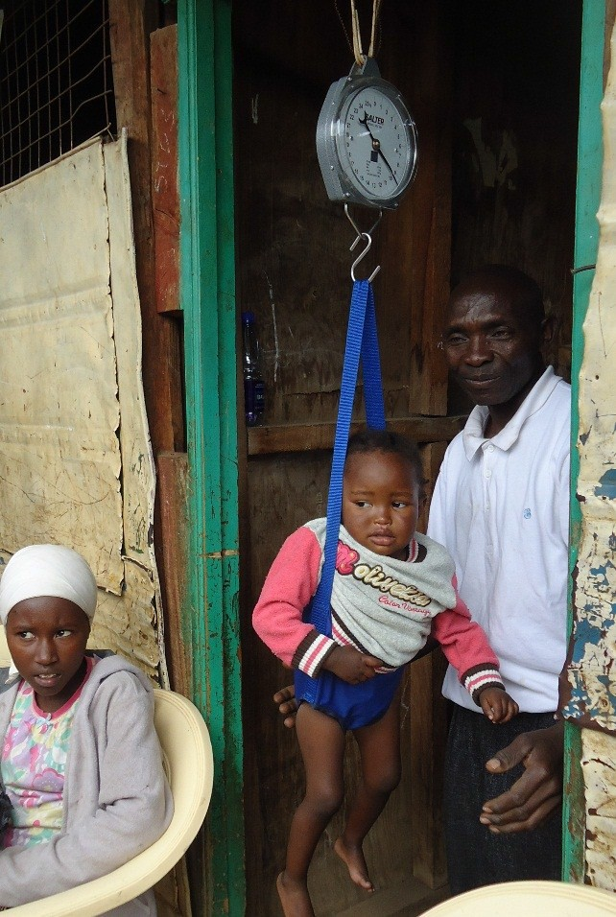
Range of services that can be offered during integrated
outreaches
- Family planning
- HIV Counseling and Testing
- Antenatal services,
- Immunization,
- Growth monitoring,
- Insecticide Treated Net distribution
♦
♦

♦

♦

♦
TB screening
Screening & Treatment of minor ailments e.g BP readings
General counseling – e.g. drug abuse, youth
Nutritional screening
Cervical cancer screening

Clients rights during outreach services

- Information: Service providers should ensure that clients receive adequate information regarding the services provided. Clients need to be informed about the services provided and costs involved (if any). Clients interested in a particular method need to know how it works and how to obtain/ use it, the importance of follow-up, information about potential side effects and how to manage them, warning signs, and the protection from STIs (including HIV/AIDS) that the FP method may or may not offer. Clients also need to be informed about how to switch to another method if they so desire.
- Informed Choice: Clients should be counseled on the range of contraceptive options and methods that are available at the outreach and nearby referral facilities, and should be provided with accurate and complete information to enable them to make an informed decision.
- Safety of services: Service providers should adhere to infection-prevention practices and client instructions for effective use of the contraceptive method (see Appendix 4)
- Privacy and confidentiality: Care should be individualized and discrete. Clients should be protected from both auditory and visual exposure. Client information should be protected from access by anyone who is not directly involved in his or her care.
- Access to Services: All clients, including adolescents and people with disabilities, have the right to FP services at all levels of care. Service delivery points should be clean, well organized, and adequately supplied with quality contraceptives. Clients should not have long waiting times and should be able to obtain the contraceptive of their choice.

IMPLEMENTATION OF RH/FP OUTREACH HEALTH SERVICES

Promotional / Mobilization activities
Proper planning is critical to the success of an outreach; it invoves meetings the sub county service delivery and community work focal persons who takes lead in the implementation of the outreach.
It is important to create demand for outreach FP/RH services, inform the community about FP, and combat any misinformation and rumors about certain methods. FP/RH can be promoted through;

Continuous group health education is critical to increasing service uptake
- Community Health Volunteers
- IEC campaigns (posters, brochures etc)
- Mass media campaigns - TV, Radio advertisements
- Health talks at surrounding health facilities, churches
- Use of local implementing partners, community based organizations, women’s/men’s “chamas”
- Community meetings such as during Chief’s Barazas, Church gatherings
Orienting Staff for Outreach Services
Efforts should be made to target men during promotional activities

As some clinical staff conducting FP/RH outreach services may not be conversant with all the services being provided, it is recommended that a one-day orientation session be held before the outreach activities. This can be done the day preceding the start of outreach services. This day can also serve as an opportunity to review all logistical preparations.

Referral

SUGGESTED REFERENCE MATERIALS FOR STAFF ORIENTATION
1. FP National Standards
2. WHO Global Handbook for Service Providers
3. MOH Job aids- How to be reasonably sure a client is not pregnant, Implants job aid, IUCD job aid
4. FP Daily Register
5. Medical Eligibility Criteria
6. Monitoring and Evaluation tools
7. Cervical cancer screening photo atlas
7. Outreach data reporting form(MOH 711)

Not all services may be offers during outreaches. Hence, plans for referral should be made. These include;
  - Identifying referral facilities
  - Availing referral tools
  - Orienting outreach teams and link facilities on referral processes
Emergency Preparedness

Outreach services involve large numbers of clients, the team should prepare for emergency situations e.g. fainting, very sick clients, or accidents. As part of emergency
preparedness the outreach team should plan which health facilities within the vicinity of the outreach camp should serve as the immediate referral points. A list of emergency preparedness is on Appendix 1

Where feasible, arrangements for a standby ambulance should be made.
With nearby health facilities

Monitoring and Evaluation of Outreach Health Services
FP data collection tools during outreach activities

    - Daily Activity Register: It is recommended that health facilities that are involved in outreach activities maintain a separate daily activity register for use in outreach activities. Outreach data should be combined with facility data when compiling monthly data summaries.
- Outreach attendance registers: To record the total number of clients attending integrated outreach services for various services
- Contraceptive Consumption Data Report (CDRR) Forms : Facilities should use these for ordering FP commodities including for outreach camps
- Community referral forms: For use in referring clients from outreach sites to nearby health facilities.

Post Outreach Camp Follow Up

- 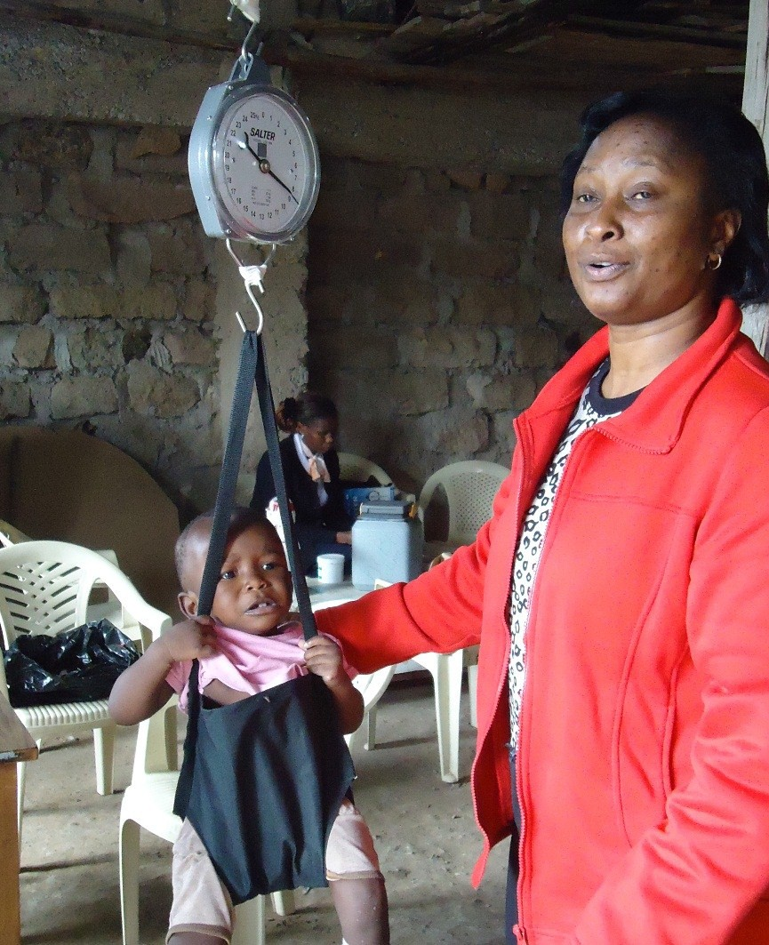After the outreach activity, the team should have a meeting to review the activity. The following can be discussed and reviewed;
  - Successes and lessons learnt
  - Quality of services
  - Challenges and ways of overcoming them
  - Infection prevention e.g. Processing of used instruments, disposal of clinical wastes
  - Plan for follow up within the facility or community
  - Data and report compilation

POSSIBLE CHALLENGES TO CONSIDER

Transport Difficulties
This includes poor road infrastructure in most rural areas, which is especially a problem during rainy seasons.

- Schedule outreach visits during non-rainy seasons.
- In the case of political instability, there might be a need to focus more on static services rather than outreach, at least temporarily.

Financial Constraints
This may include difficulties in covering the cost of vehicles, fuel, logistical preparations, cost of IEC and promotional materials, cost of commodities and other consumables . Look for cost- sharing arrangements with partners and with other programs (i.e., HIV/AIDS, immunization, malaria, vitamin A) when integrated services are provided.

Inadequate Demand

Ensure that community mobilization occurs, along with a range of methods to advertise services, including posters, radio, and word-of-mouth. Conduct more participatory educational activities. Involve men and youth, and include games and role-playing.

Follow-up care and support
Work with CHVs to assist with follow-up of clients.

Commodities
When there are no commodities, outreach services cannot take place. When possible, explore government partnership for the provision of contraceptive methods. Keep good records to ensure proper forecasting and planning for the number of services needed.
Services disruption at Outreach Team’s Home facility

Try to involve providers from adequately staffed clinics so they are able to function without some of their staff. Consider mobilizing staff from surrounding facilities to minimize service disruption to the home facility.

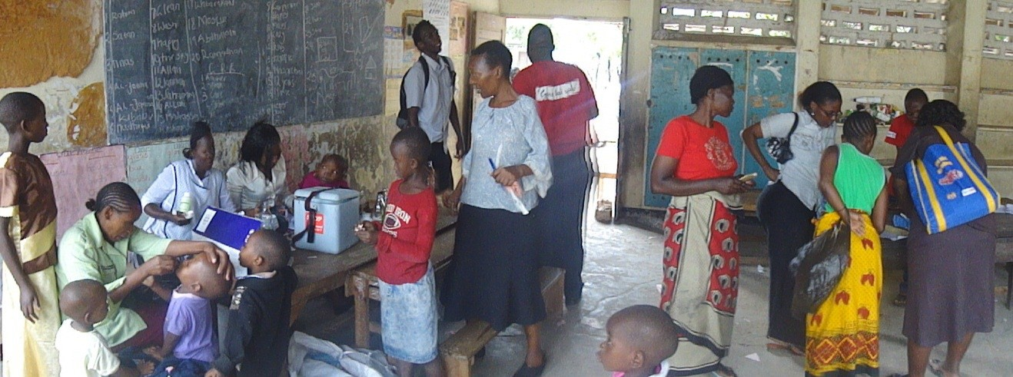

SUMMARY OF MAIN ACTIVITIES IN IMPLEMETING AN RH/FP OUTREACH SERVICE

- SCHEDULING FP/RH OUTREACH SERVICES
Use health data to make decisions on;
  - Need for outreach services
  - Type of services to offer
  - Location of services
Agree on location of outreach with SCHMTs and other stakeholders. Consider
  - Water supply,
  - Source of electricity /Generator available
  - Toilet facilities
Schedule dates of outreach and mobilization/promotion activities Obtain necessary approvals e.g.
  - NEMA licence, Municipal council licences, Community facilities e.g. social halls
Conduct 2 - 4 planning meetings as necessary
- PREPARING OUTREACH SITE FOR SERVICE DELIVERY
Collaboratively identify a site coordinator for the outreach activity
Agree where clinical services will be conducted (in health facility, community location, mobile wagons etc ) Orient (knowledge and skills) clinical staff on the outreach services that will take place 2 - 3 days prior to Buildings to use for clinical services should have;
  - Washable floors
  - Adequate number of procedure rooms
  - Rooms for private counselling
Use equipment and supply checklists to determine materials that are insufficient/lacking Order required equipment and supplies at least 3 weeks prior to outreach activity
Organise transport as necessary for staff, equipment and supplies
3. INFORM CLIENT BASE
Conduct community mobilisation and information activities (e.g. Mass media, print materials, community meetings, CHVs
4. CREATE MONITORING / EVALUATION PLAN
Ensure availability of necessary service statistics registers and client record forms Collect service statistics and other demographic data and summarise on a daily basis
Hold progress review meeting (s) with health management teams and stakeholders to re-plan as re-strategize accordingly
5. PLAN FOR REFERRAL AND FOLLOW UP
Set up system for referral, follow up and continuity of care;
Identify how and where complications/side effects will be managed (after the outreach) Identify health facilities to serve as referral facilities
Prepare adequate referral tools and use appropriately
Prepare means of client transport in case of emergency referrals
6. ENSURE QUALITY OF SERVICES
Use good counselling techniques Ensure informed client choice Ensure privacy and confidentiality Proper infection prevention measures

Appendix 1: OUTREACH/INREACH FP SUPPLY CHECKLISTS

Equipment and Supplies |  |  | Min.  Quantities | Yes | No | Comments
1 |  | STATIONARY
2 |  | First visit card
3 |  | FP Daily Activity register
4 |  | Outreach Summary tools
5 |  | Follow up cards
6 |  | Client Referral Forms
7 |  | Stamp and Stamp pad
8 |  | Writing pens
9 |  | Consent forms (for BTLs and Vasectomy)
FP EQUIPMENT (see charts for details)
1 |  | IUCD insertion/removal sets
2 |  | Implant insertion sets
3 |  | Implant removal sets
4 |  | BTL sets *
5 |  | Vasectomy Sets *
FP COMMODITIES
1 |  | Progestin Only Pills
2 |  | Combined Pills
3 |  | Emergency Pills
4 |  | Male condoms
5 |  | Female condoms
6 |  | Cycle Beads
7 |  | Implants
8 |  | IUCD (Copper T)
9 |  | Depo-Provera Injections

Ap pe nd ix 1: OUTREACH/INREAC H FP SUPP LY CHECKLISTS

 | Equipment and Supplies | Available ? |  | Minimum quantities | Comments
 |  | Yes | No
 | OTHER EQUIPMENT & SUPPLIES
1 | Blood pressure machine
2 | Adult weighing scale
3 | Thermometer
4 | Examination tables / Couches
5 | Screens
6 | Light sources
7 | Stethoscope
8 | Sanitary Pads
9 | Linen / disposable mackintosh ()
10 | Latex gloves
11 | Sterile gloves (7.5, 8.0)
12 | Sterile gauze pack (s)
13 | Local anaesthetics (Lignocaine 1%)
14 | Disposable needles and syringes
15 | Cotton/Alcohol swabs
16 | Antiseptic (Hibitane)
17 | Acetic Acid
18 | Lugol’s Iodine
19 | Elastoplast
 | INFECTION PREVENTION EQUIPMENT AND SUPPLIES
1 | Autoclave*
2 | Gluteraldehyde (Cidex)
3 | Chlorine solution
4 | Sterile drums
5 | Hand-washing facility (Working sinks /“Veronica” bucket)
6 | Alcohol hand scrub
7 | Aprons / Lab coats
8 | Utility gloves
9 | Water proof (utility) apron
10 | Puncture resistant sharps container
11 | Waste Bins
12 | Bin liners

Appendix 1: OUTREACH/INREACH FP SUPPLY CHECKLISTS

 | Equipment and Supplies | Available ? |  | Minimum quantities | Comments
 |  | Yes | No
 | Emergency Equipment/ Medicine
1 | First aid Kit
2 | IV insertion sets
3 | IV Fluids (Normal Saline, Dex- trose, Ringers lactate, Hae- maccel)
4 | Adrenaline 1mg/ml
5 | Hyrdocortisone
6 | Diazepam 10mg injections
7 | Inhaler (bronchodilator)
8 | Ambu bag and mask
9 | Oral airway (Size 3,4)
10 | Elastic bandages 3’’, 4’’, 6’’
11 | Oral Rehydration Salts (ORS)
 | Others
1 | Toilet facilities
2 | Incinerator
3 | Drinking water
 | SERVICE PROVIDER JOB AIDS
1 | WHO MEC wheels
2 | Provider Initiated FP job aid
3 | FP Screening checklists;  - How to be reasonably sure client is not pregnant  - Screening for IUCD  - Screening for Implant  - Screening for Injectables
 | Promotional Materials
1 | Banners
2 | Client brochures /pamphlets

Appendix 1: OUTREACH/INREACH FP SUPPLY CHECKLISTS

 | Equipment and Supplies | Available ? |  | Minimum quantities | Comments
 |  | Yes | No

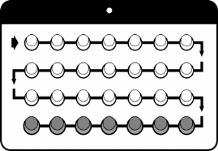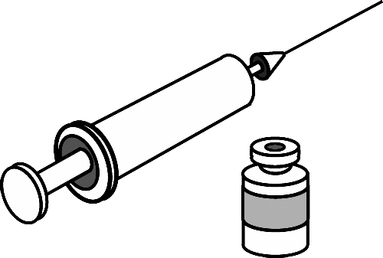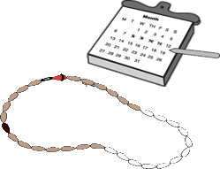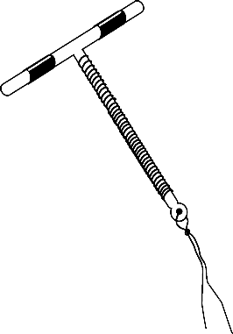APPENDIX 2 : CHECKLIST FOR KEY FP COMMODITIES

FAMILY PLANNING COMMODITIES FOR OUTREACH FP ACTIVITIES
FP Commodity Item Quantities

Oral contraceptives pills (Progestin only and combined pills)

Emergency Contraceptive Pills

Depo Provera

Cycle Beads

Implants (Jadelle, Implanon , Zarin)

Intrauterine Contraceptive Devices

Male Condoms

Female Condoms

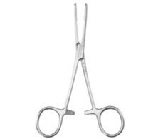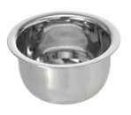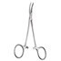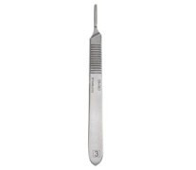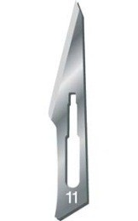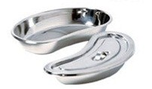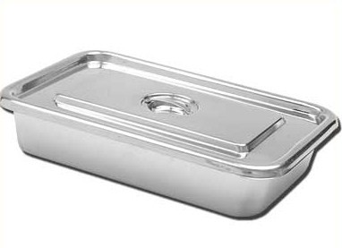APPENDIX 3: CHECKLIST FOR FP EQUIPMENT :

IMPLANT INSERTION AND REMOVAL EQUIPMENT

Equipment Item Quantity

Sponge holding forceps

Gallipot

Curved Mosquito forceps

Scalpel Handle (No. 3) for Jadelle, Zarin

Surgical blade (No. 11) for Jadelle, Zarin

Sterile towels

Instrument tray or covered kidney dish

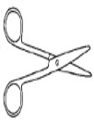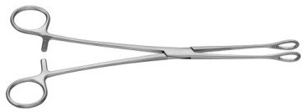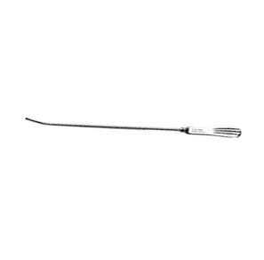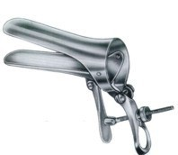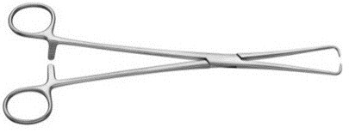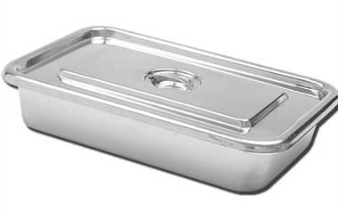

APPENDIX 3: CHECKLIST FOR FP EQUIPMENT

IUCD INSERTION AND REMOVAL EQUIPMENT
Equipment Item Quantity

Scissors

Small Rampley sponge holding forceps

Uterine sound

2 Cusco’s Speculums (medium, small)

Tenaculum Forceps

Covered instrument tray

Sterile towels

Appendix 4: INSTRUMENT PROCESSING STEPS

DECONTAMINATION
Soak in 0.5% chlorine solution for 10 minutes or enzymatic detergent for 5 minutes

Preferred
CLEANING
Wear gloves and appropriate PPE. Thoroughly wash with soap and rinse to remove all blood and tissue from instruments
Method
Accept
ed methods

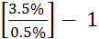

Chemical
Glutaraldehyde 2% for 10 hours
Boil or Steam
Completely covered (immersed) at roll- ing boil with a lid on, for 20 minutes

Chemical
Glutaraldehyde 2% for 30 minutes Orthophaldehyde for 5 minutes
Chlorine 0.1% (prepared using boiled water for 10 minutes)

From: National Infection Prevention and Control Guidelines for Health Care Services in Kenya
Autoclave
106k (15lb/in2) pressure, 121⁰C
Unwrapped for 20 minutes / wrapped for 30 minutes
Dry Heat
170⁰C for 60 minutes
Cool and use immediately OR
Store in a covered sterile container

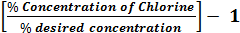
DILUTING CHLORINE SOLUTION
Check concentration (% concentrate ) of the chlorine product you are using To determine total parts of water needed use the formula:

Parts of water =
e.g. to prepare a 0.5% concentration of chlorine from a 3.5% chlorine solution

Parts of water = Parts of water = 6
Add 6 parts of water to 1 part of chlorine solution.

Steps and Time lines for Outreach Camps
20

A Month before the out- reach | Step 1  Planning meeting with stake holders and SCHMT  teamAgs:ree on date of outreach Location  Assign facility to link the outreach  Identification of other partners conducting the activity | Step 2  Identification of other partners in the area and establish linkages | Step 3  Needs assessment of location: with empha- sis on the lack of ser- vices and access to health service | Step 4  Decide on ser- vices for inte- gration. With the SCHMT | Step 5  Get the quantification of commodities re- quired for the outreach from the facility
Three weeks before the out- reach | Step 6  Check on availability of staff skills for the services to be provided | Step 7  Agree on the FP services to the provided at the outreach camp. | Step 8  review the transport needs for the facility and the team | Step 9 Ordering of equipment to be used in the health wagon | Step 10  Start of Mobilization activities.  Putting up of posters to advertise the outreach
Two weeks before the out- reach | Step 10  Community meetings at the chiefs Baraza, churches with health talks and community education | Step 11  Hiring the hall/ church/ orders for tents for the outreach
Three days be- fore the out- reach | Step 12  Community mobilization to begin, by the CHVs | Step 13  Receiving of the equip- ment for the wagon and the outreach | Step 14  Ensuring that all equipment and com- modities are in place and the necessary re- porting tools/Forms. | Step 15 Orientation of the health workers for the outreach.

How to be Reasonably Sure a Client is Not Pregnant
Ask the client questions 1--6. As soon as the client answers YES to any question,
stop, and follow the instructions.

NO | Did you have a baby less than 6 months  1 ago, are you fully or nearly-fully  - breastfeeding, and have you had no  menstrual period since then? | YES
NO | Have you abstained from sexual  2. intercourse since your last menstrual period or delivery? | YES
NO | 3. Have you had a baby in the last 4 weeks? | YES
NO | Did your last menstrual period start within  4. the past 7 days (or within the past 12 days if you are planning to use an IUCD)? | YES
NO | Have you had a miscarriage or abortion in  5. the past 7 days (or within the past 12 days if you are planning to use an IUCD)? | YES
NO | Have you been using a reliable  6. contraceptive method consistently and correctly?
 |  | YES

If the client answered NO to all of the questions, pregnancy cannot be ruled out. The client should await menses or use a pregnancy test.
If the client answered YES to at least one of the questions and she is free of signs or symptoms of pregnancy, provide client with desired method.
© 2010

Republic of Kenya
This publication has been made possible through support from the U.S. Agency for International Development (USAID).

Checklist for Screening Clients Who Want to Initiate Use ofthe Copper IUCD
First, be reasonably sure that the client is not pregnant. If she is not menstruating at the time of her visit, ask the client questions 1-6. As soon as the client answers YES to any question, stop, and follow the instructions after question 6.
-

-
YES | 1. Have you had a baby in the last 4 weeks? | NO
YES | Did you have a baby less than 6 months ago, are you fully or nearly-fully breastfeeding,  2. and have you had no menstrual period since then? | NO
YES | 3. Have you abstained from sexual intercourse since your last menstrual period or delivery? | NO
YES | 4. Did your last menstrual period start within the past 12 days? | NO
YES | 5. Have you had a miscarriage or abortion in the last 12 days? | NO
YES | 6. Have you been using a reliable contraceptive method consistently and correctly? | NO

-
-
-
-
-
0 0

If the client answered YES to any one of questions 1-6 and she is free of signs or symptoms of pregnancy, you can be reasonably sure that she is not pregnant. Proceed to questions 7-14.
However, if she answers YES to question 1, the insertion should be delayed until 4 weeks after delivery. Ask her to come back at that time.
Ifthe client answered NO to all of questions 1-6, pregnancy cannot be ruled out. The client should await menses or use a pregnancy test.
To determine if the client is medically eligible to use an IUCD, ask questions 7-14. As soon as the client answers YES
to any question, stop, and follow the instructions after question 14. -
-
NO | 7. Do you have bleeding between menstrual periods that is unusual for you, or bleeding after intercourse (sex)? | YES
... NO | 8. Have you been told that you have any type of cancer in your genital organs, trophoblastic disease, or pelvic tuberculosis? | YES
... | 9. Have you ever been told that you have a rheumatic disease such as lupus? | YES
... NO | 10. Within the last 3 months, have you had more than one sexual partner? | YES
 | 11. Within the last 3 months, do you think your partner has had another sexual partner? | YES
NO  ... NO | 12. Within the last 3 months, have you been told you have an STI? | YES
... NO | 13. Within the last 3 months, has your partner been told that he has an STI, or do you know if he has had any symptoms - for example, penile discharge? | YES
... NO | 14. Are you HIV-positive, and have you developed AIDS? | YES

r+
r+
NO r+
-
r+ r+ r+
r+
0
If the client answered NO to all of questions 7-14, proceed with the PELVIC EXAM.

If the client answered YES to any of questions 7-9, an IUCD cannot be inserted. Further evaluation of the condition is required.
If the client answered YES to any of questions 10-13, she is not a good candidate for an IUCD unless chlamydia and/or gonorrhea infection can be reliably ruled out.
If she answered YES to the second part of question 14 and is not currently taking ARV drugs, IUCD insertion is not usually recommended. If she is doing clinically well on ARVs, the IUCD may generally be inserted. HIV-positive women without AIDS also generally can initiate IUCD use.

-
During the pelvic exam, the provider should determine the answers to questions 15-21.
-
-
-
-
-
- NO

If the answer to all of questions 15-21 is NO, you may insert the IUCD.
-
r+
NO | 15. Is there any type of ulcer on the vulva, vagina, or cervix? | YES
NO | 16. Does the client feel pain in her lower abdomen when you move the cervix? | YES
NO | 17. Is there adnexa tenderness? | YES
NO | 18. Is there purulent cervical discharge? | YES
NO | 19. Does the cervix bleed easily when touched? | YES
NO | 20. Is there an anatomical abnormality of the uterine cavity that will not allow appropriate IUCD insertion? | YES
 | 21. Were you unable to determine the size and/or position of the uterus? | YES

r+ r+ r+
r+ r+ ,

This publication has been made possible through support from
If the answer to any of questions 15-21 is YES, the IUCD cannot be inserted without further evaluation. See explanations for more instructions.
the U.S. Agency for International Development (USAID). Republic of Kenya © 2010

Checklist for Screening Clients Who Want to Initiate Contraceptive Implants
To determine if the client is medically eligible to use implants, ask questions 1-6. As soon as the client answers YES to any question, stop, and follow the instructions after question 6.

-
NO | 1. Have you ever been told you have breast cancer? | YES
NO | 2. Do you currently have a blood clot in your legs or lungs? | YES
NO | 3. Do you have a serious liver disease or jaundice (yellow skin or eyes)? | YES
NO | 4. Have you ever been told that you have a rheumatic disease, such as lupus? | YES
NO | Do you have bleeding between menstrual periods, which is unusual for you, or  5. bleeding after intercourse (sex)? | YES
NO | 6. Are you currently breastfeeding a baby less than 6 weeks old? | YES

""""
-

""""
""""
-
...
r.
r.

r.
r.

'II 'II

If the client answered NO to all of questions 1-6, she can use implants. Proceed to questions 7-12.
If the client answered YES to question 1, she is not a good candidate for implants. Counsel about other available methods or refer.
If the client answered YES to any of questions 2-5, implants cannot be initiated without further evaluation.Evaluate or refer as appropriate, and give condoms to use in the meantime. See explanations for more instructions.
If the client answered YES to question 6, instruct her to return for implant insertion as soon as possible after the baby is six weeks old.
Ask questions 7-12 to be reasonably sure that the client is not pregnant. As soon as the client answers YES to any question, stop, and follow the instructions after question 12.
- """"
-
YES | 7. Did your last menstrual period start within the past 7 days? | NO
YES | 8. Did you have a baby less than 6 months ago, are you fully or nearly-fully breastfeeding, and have you had no menstrual period since then? | NO
YES | 9. Have you abstained from sexual intercourse since your last menstrual period or delivery? | NO
YES | 10. Have you had a baby in the last 4 weeks? | NO
YES | 11. Have you had a miscarriage or abortion in the last 7 days? | NO
YES | 12. Have you been using a reliable contraceptive method consistently and correctly? | NO

""""
""""
""""
""""
'II 'II

Ifthe client answered YES to at least one of questions 7-12 and she is free of signs or symptoms of pregnancy, you can be reasonably sure that she is not pregnant. The client can have implants inserted now.
If the client began her last menstrual period within thepast 7days (5 daysfor Imp/anon), she can have implants inserted now. No additional contraceptive protection is needed.
If the client began her last menstrual period more than 7 days ago (5 daysfor Implanon), she can have implants inserted now, but instruct her that she must use condoms or abstainfrom sex for the next 7days.Give her condoms to use for the next 7 days.

Ifthe client answered N0 to all of questions 7-12,pregnancy cannot be ruled out.
She must use a pregnancy test or wait until her next menstrual period to have implants inserted.
Give her condoms to use in the meantime.

This publication has been made possible through support from the U.S. Agency for International Development (USAID).

Republic of Kenya

© 2010

Checklist for Screening Clients Who Want to Initiate DMPA (or NET-EN)
1odc1crminc if 1hc cliclllis medically eligible 10 use DMPA, ask qucs1ons 1-8. As soon as tl c cl elll answers YES 10
any-question, s1op,and follo\v tJ1cinstruc1ions after question 8.
NO -
-
 | I. J lave you ever been told you have breast c.ancer? | YES
NO | 2. Have youever had a SLtOkeor hean auack,or do you cwcmly havea blood clotin your legs or lungs? | YES
-  NO | 3. Do you have a serious liverdisease or jaundice (yellO\\' skinor eyes)? | YES
NO | 4. Ilave you ever been 1old you have diabetes (high sugarin your blood)? | YES
 | 5. Have youever been 1old you have highblood pressure' | YES
NO | 6. Do you have bleeding bc1,vccn rncnstrualperiods \vhi<:his unusual br you. or bleeding after intercourse (sex)? | YES  YES YES
 | 7. l lavc you ever been told that you have a rhcuma1ic disease such as lupus·?
, NO | 8 Are you currently breastfeeding. a baby less than 4'1ccks old'?

.,
-

.,
-

.,
-
NO .,
-

.,

If the clenlanswered NO to all of q11estio11s 1-8, the clien1can use DMJ>A .
Proceed toqucs1ions 9-14.
,-
-
NO
.,
.,
If theclient ans\vcrcd \'ES to questiot1 I. she is not a good candidate for DMP1\ .
Counsel about other available incthodsor refer.
If Iil c cliem answered YES toa11y of q11estio11s 2-7.DMPA cannot beinil atcd
\\'ithout further evaluation . EvaJuatc or refer as appropriate.and give condo1ns to
use in the mcaruimc. Sec explanat ons for inorc instn1ctions.
If 1hcclient .inswcred YESto q11estio11 8.insiruct her 10 rcium for DM PA as soon
as possible af1er the babyis four weeks old.
••

Ask Quest ons 9-14 to be reasonably sure that the client is not pregnant. Assoon as the client ans\vers Y•S to an.v
question,stop, and follo'v the insLructions after quest.ion 14.

...
YES | 9. Did your last 1ncnsltuaJ period start'vithin the past 7 days? | NO
YES | 10. Did you have a babyless 1han 6 mon1hs ago.are you fully or nearly-fully  breastfeeding. and have you had no 1nenstrualperiod since then? | NO
YES | IJ. l lave you abstained fro1n sexual intercourse since your last 1nenstrual period or delivery? | NO
YES | 12. Have you had a babyin tl1elas14 weeks? | NO
YES | 13. f-lave you had a miscarriage or abo11ion in the last 7 days'! | NO
YES | 14. f-lave you been using a reliable contn1ceptive method consistently and correctly'! | NO

•
•
•
•
ff tl>e client answered YFJ5 to at least 011e of q11estio11S 9-14and sheis free of signs or S)1mptoms of pregnancy,you can be ret1sonably sure that she is not pn;gnant. 111c cl ient can stan DMPA no,v.
lf the client beg_ l her last 1nenstrual period u•ilhi11 tlte past 7 days. she can start DMPA im1nediately.No additional contraceptive protection is needed.
If the client began her last 1ncnstn1al period 111ore tlra11 7days ago. she can be given Dft1PA now,but instruct her that she must use co11do111s orabstain fro 111 sexfor the 11exl 7days. Give her condoms 10 use for the next 7 days.
,•
lb.i• pi.abl1('rtltOQ h.¥ lx -u nia<k po!!81biot lhrou,gb srt fro111
1M U.S. A y for ln1emiQ.Ji.I CX\ c1¢pmtt11(USAJO).
-

-
-
-
-
-,,

Ifthe client answered NO 1oall of questions 9-14. pregnancycanno1be nied out.
She rnust use a pregnancy test or'vait until her ncx.1 1ncnsLtual period tobe g.ivcn DMPA.
Give her condoms to use in the meantime.

02010

Informed and Voluntary Consent Form for Surgical Contraception

I,
following procedure:
, the undersigned , wish to be sterilised by the

I understand the following;
- There are temporary methods of contraception that I can use instead of sterilisation for family planning.
- Sterilisation is a surgical procedure, the details of which my doctor, nurse, or midwife has explained to me.
- The sterilisation operation carries certain risks, complications, and side effects, which my doctor, nurse, or midwife has explained to me.
- The sterilisation procedure will permanently prevent future pregnancies.
- The sterilisation procedure is considered permanent and probably cannot be reversed.
- I know that I can change my mind and decide against the procedure at any time before the procedure is done, and I will continue to be provided with medical services from my doctor, nurse, or midwife.

……………………………………………….. Date: ………………………………………………………………….. Client’s name (print)

……………………………………………….. Date:………………………………………………………………….. Client’s signature

……………………………………………….. Date:…………………………………………………………………..

Spousal name, when applicable (print)
………………………………………………. Date:…………………………………………………………………..

Spousal signature, when applicable
………………………………………………. Date:…………………………………………………………………..

Surgeon’s signature
………………………………………………. Date:………………………………………………………………….. Witness (can be another service provider)

Source: National Family Planning Guidelines for Service Providers—4th Edition

INTEGRATED OUTREACH SUMMARY FORM

City :
District :
Facility conducting outreach: Outreach area:
Estimated number of clients attending outreach : Total clients receiving any service at outreach:
Date: / /

A: FAMILY PLANNING SERVICES
Total clients counselled for FP:

 | CURRENT FP METHOD PROVIDED |  | FP CLIENTS |  |  | Comments
 |  |  | NEW | RE - VISITS | TOTAL
1 | PILLS | COCs
 |  | POPs
2 | INJECTION
3 | I.U.C.D | INSERTION
4 | IMPLANTS | INSERTION
5 | STERILIZATION | BTL
 |  | VASECTOMY
6 | CONDOM | MALE
 |  | FEMALE
8 | ECPS
8 | CYCLE BEADS
9 | OTHER
 | TOTAL CLIENTS

10 | REMOVALS | I.U.C.D |  | IMPLANTS

B: OTHER SERVICES

 |  | TOTAL CLIENTS
1 | HIV CT
2 | PNC
3 | CURATIVE
4 | ANC
5 | CWC
6 | IMMUNIZATION
7 | CACX SCREENING
8 | OTHER

COMMENTS:

DISTRICT:
MOH OFFICER: JOB TITLE: SIGNATURE:

Implanon nXT InserTIon Job aId

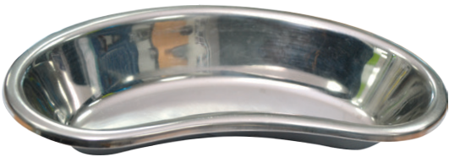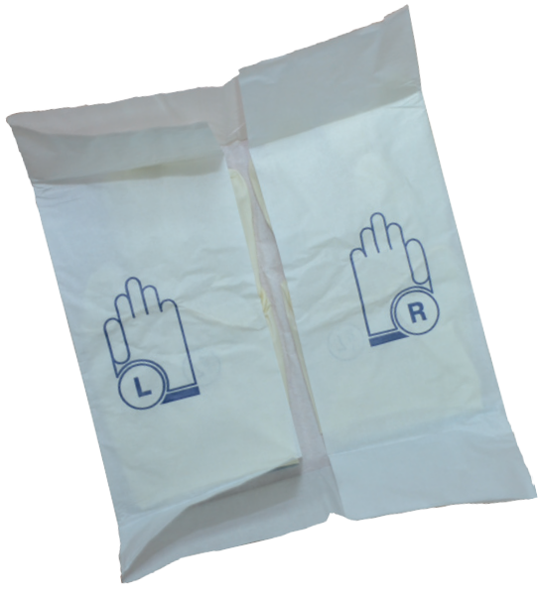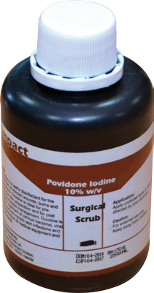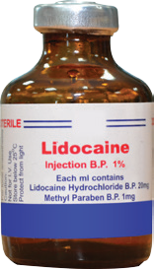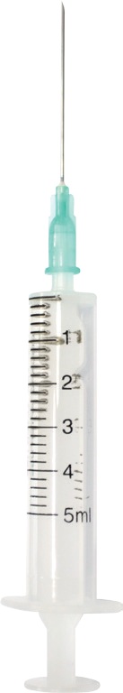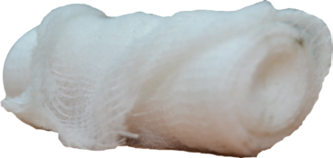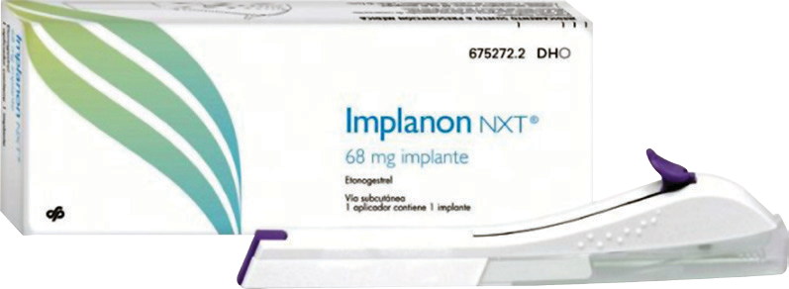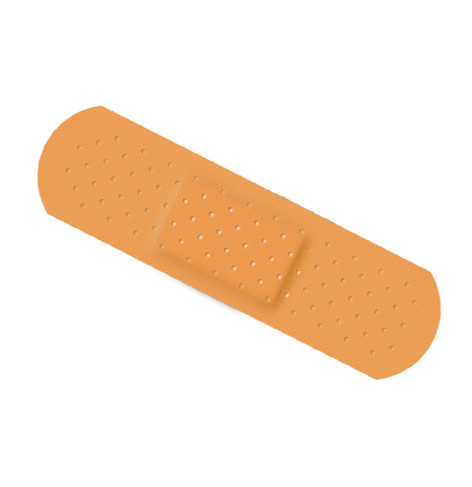reQUIremenTs For Implanon nXT InserTIon 3 5

  - Kidney dish

  - Sterile surgical drape

  - Bowl

  - Pair of sterile surgical gloves

- Sterile syringe and long needle (21-gauge)
1
- Pressure bandage 6
- Sterile gauze 2

- Antiseptic solution
- Local anesthetic (1% concentration without epinephrine)
10.
11.
Implanon NXT
4
Sterile skin closure
10 9

8 7

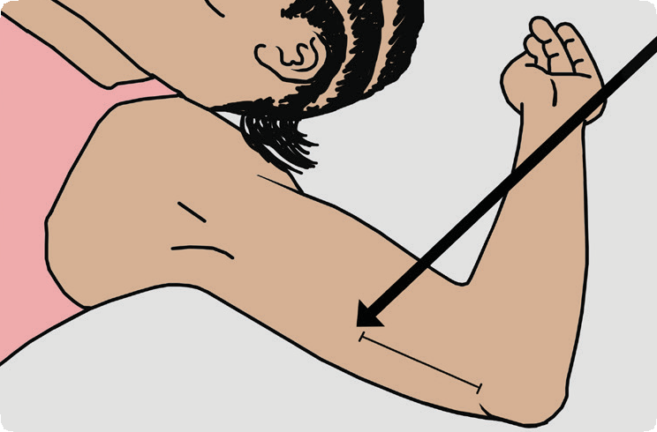sTeps For ImplanT InserTIon
1. Locate insertion
site (8 – 10 cm from
medial epicondyle of the humerus)

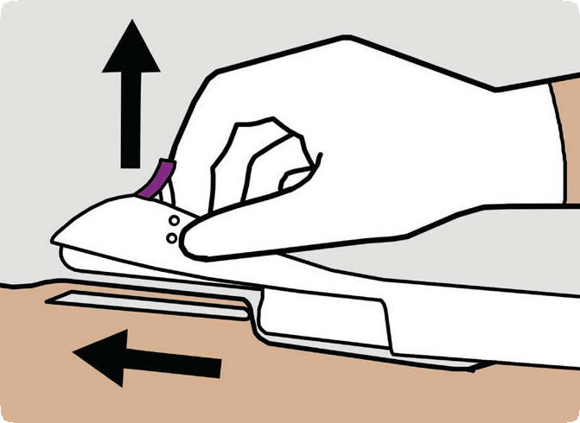
6. Lower the applicator to a horizontal position. While lifting the skin with the tip of the needle, Slide the neddle to its full length. You may feel slight resistance but do not exert excessive force

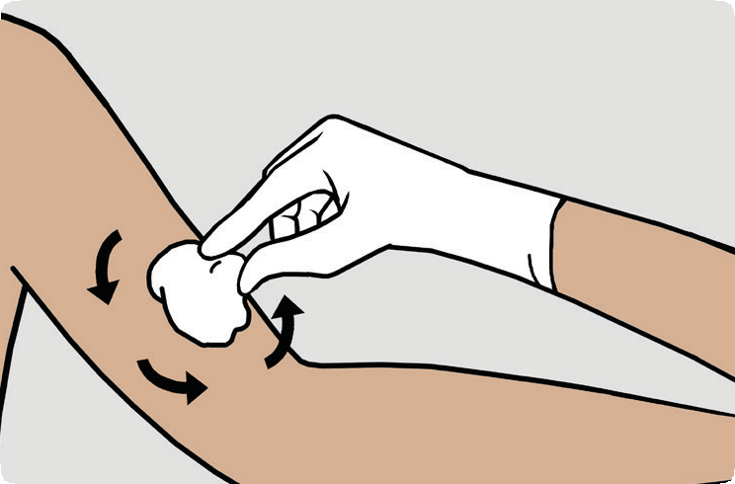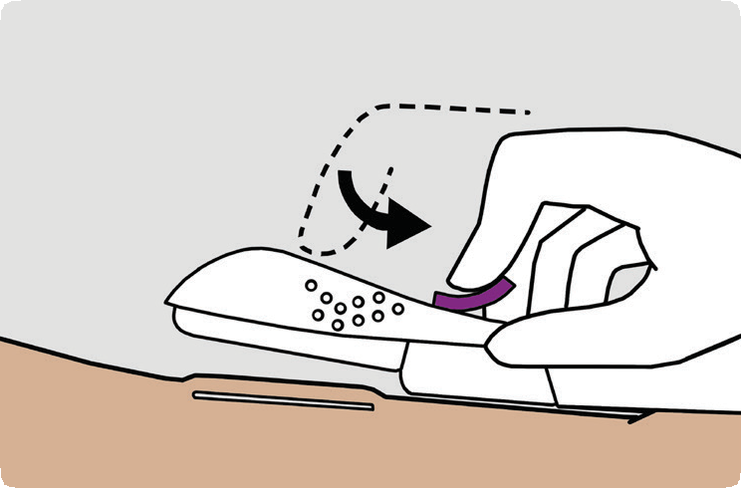

2. Clean insertion site with antiseptic twice

7. Press the purple slider downwards. Release and remove the applicator/trocar

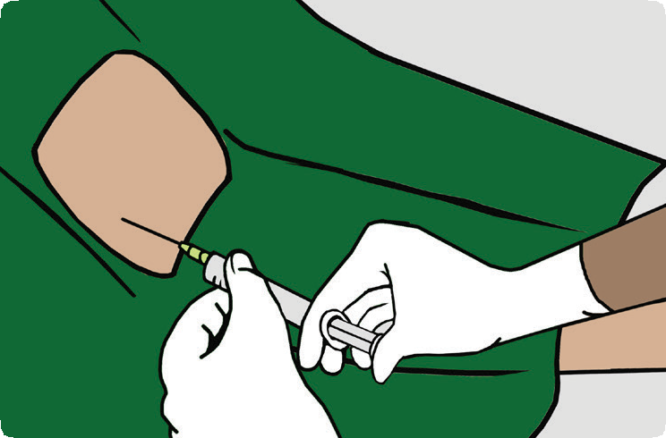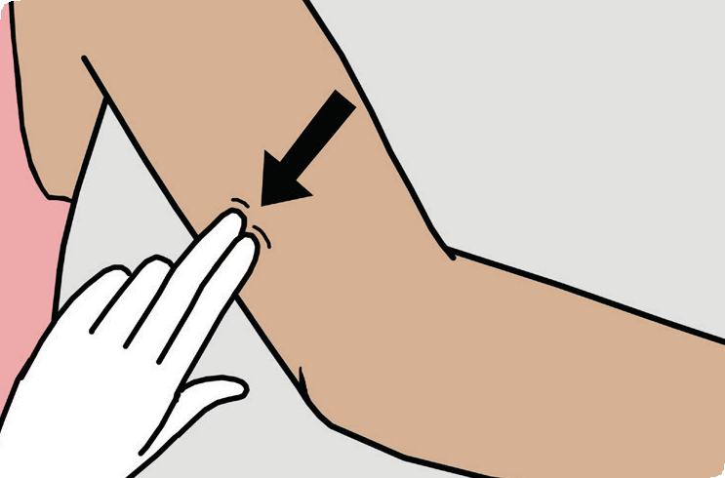

3. Anesthetise at the incision site with 1ml of 1% lignocaine (without epinephrine)

8. Verify presence of implant by palpation

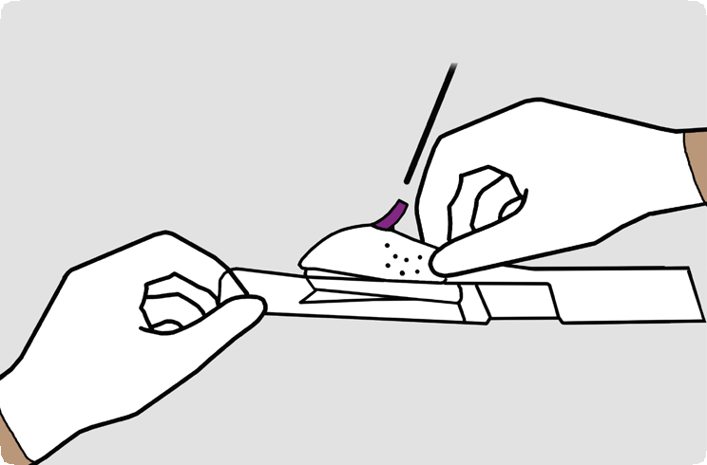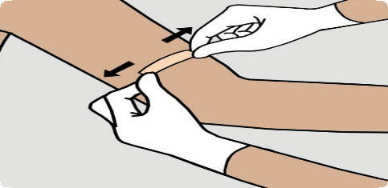
Purple slider
4. Prepare the trocar
by removing the
transparent protection cap. Do not touch the purple slider
9. Close the
insertion site
with a sterile skin closure

5. Stretch the skin around the insertion site. Puncture the skin with the tip of the needle

10. Apply pressure bandage to minimise bleeding and bruising. Client to remove bandage after 24 hrs and
sterile skin closure after 5

IMPLANT REMOVAL JOB AID

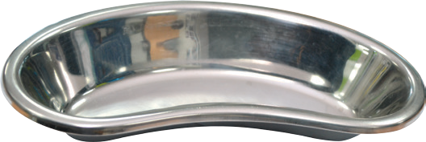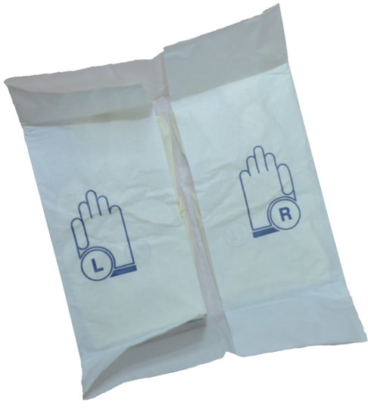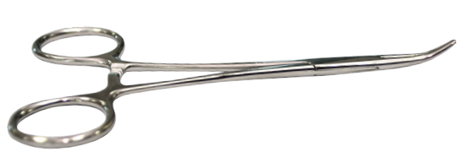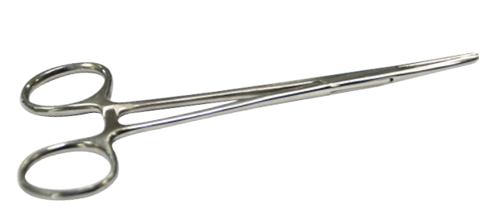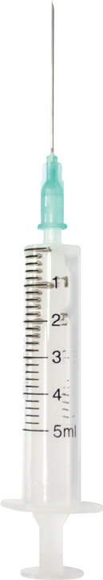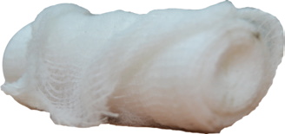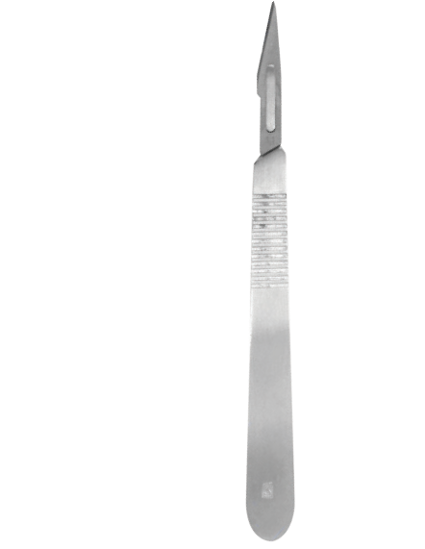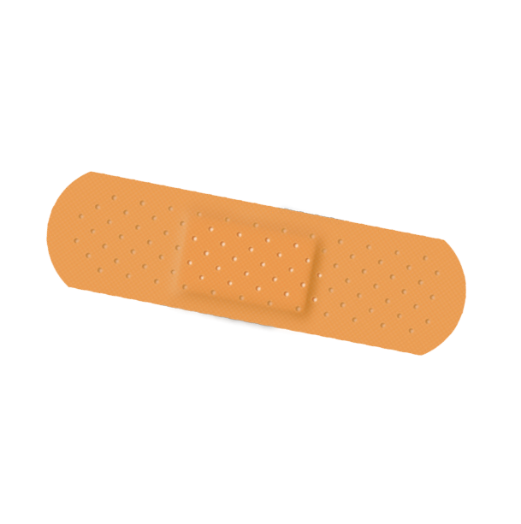REQUIREMENTS FOR IMPLANT REMOVAL 13

- Sterile surgical drape

- Bowl

- Kidney dish

- Pair of sterile surgical gloves

- Antiseptic solution

7. Sterile syringe and long needle
(21-gauge)

- 1 scalpel with blade
- 1 curved mosquito forceps 4
- 1 straight mosquito forceps

2
5

3 6
9 12 7
8

6. Local anesthetic (1% concentration
without epinephrine)
11.

12.
1132..
Pressure bandage 10
Sterile gauze
Sterile skin closure (Elastoplast) 1 11

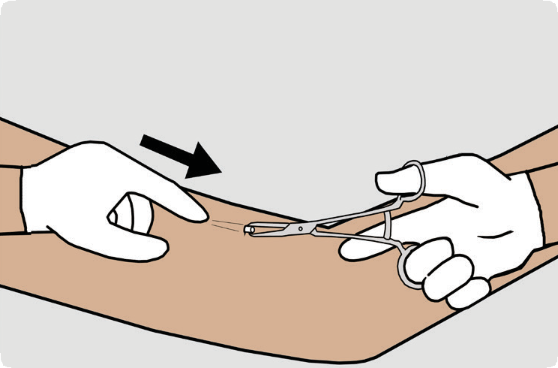STEPS FOR IMPLANT REMOVAL
5. Gently push the implant toward the incision until the tip is visible. Grasp the
implant with a curved mosquito forceps and gently remove it
- Establish the reasons for removal
- Verify the need for removal
- Establish if another implant will be inserted

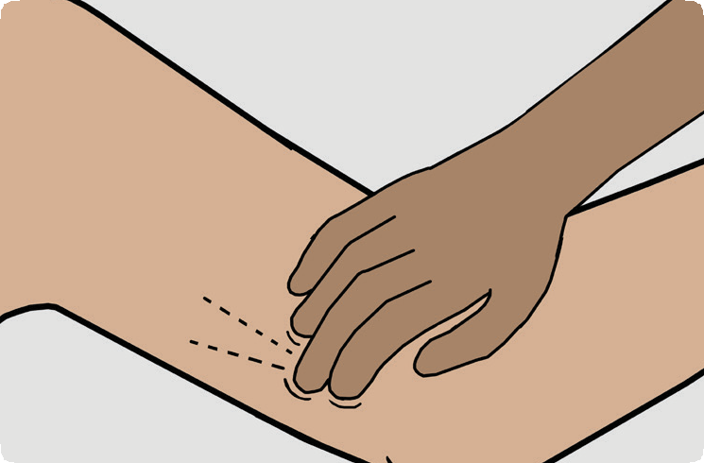

1. Locate presence of 1 or 2 rod implant by palpation. Refer for further examination if not located.
2. Clean the site with
antiseptic solution
7. Confirm that the
entire implant has
been removed.
8. If removing two-
rod implants,
repeat the procedure for the second rod.

4. Make a small (2mm)
longitudinal incision

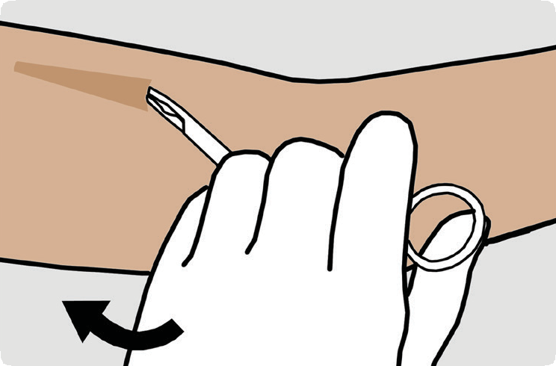

6. If the tip of the implant does not become visible in the incision, gently insert a forceps tip into the incision.

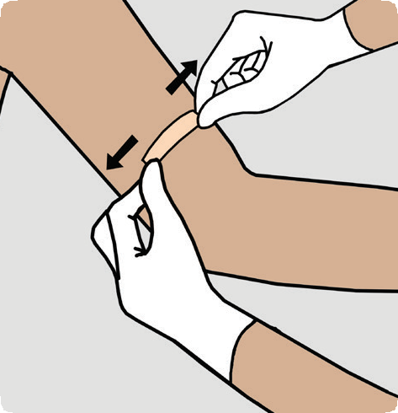
9. Press down on the
incision for a minute or so to stop any bleeding.
10. Bring the edges
of the incision
together and close with a sterile skin closure

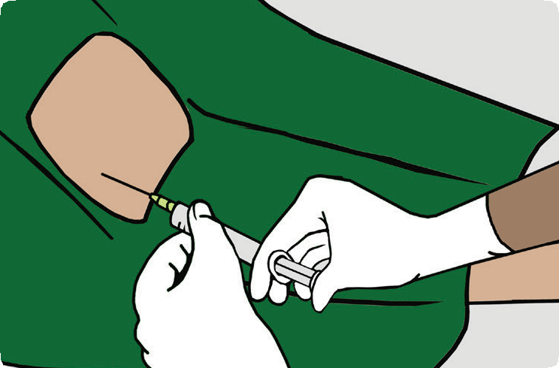11. Apply sterile gauze with a pressure bandage to minimize bruising. The woman may remove the pressure bandage after 24 hrs and the sterile

3. Anesthetise at the incision site and under the end of the capsule with upto 1ml of 1% lignocaine (without epinephrine)

NOTES

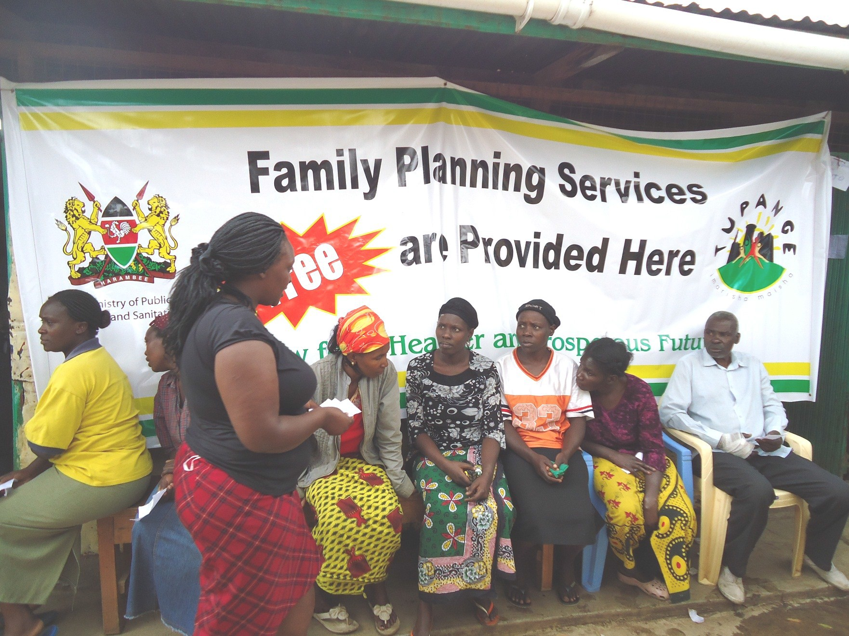

Preparation and printing of this document was made possible by support from Tupange - The Kenya Urban Reproductive Health Initiative

